Without llm = ChatOpenAI()

Initially the text file with a folder will be empty.
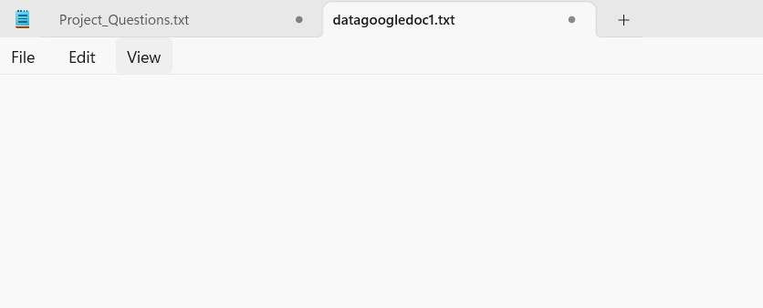
Content of Google doc
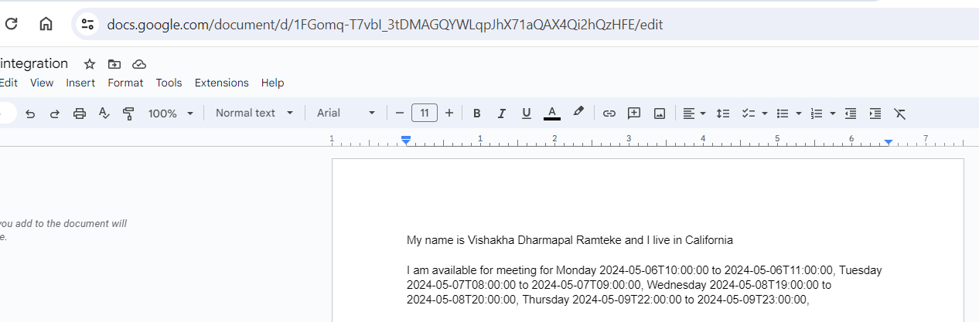

Snapshot of calendar prior to booking an event.
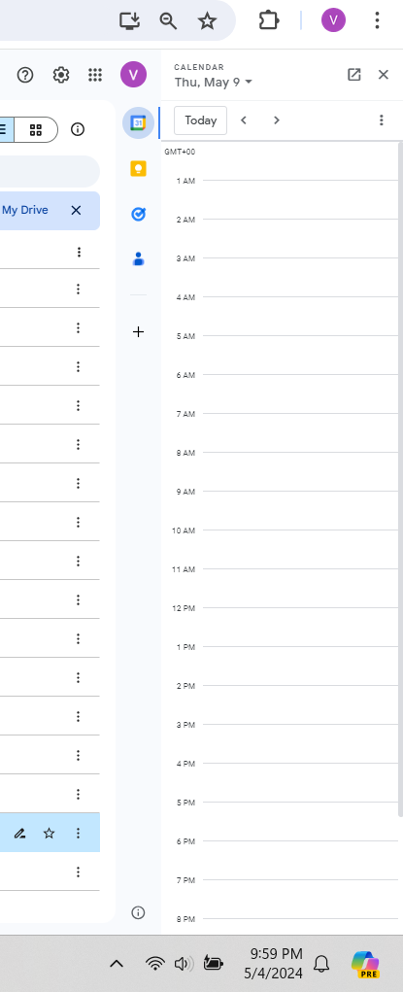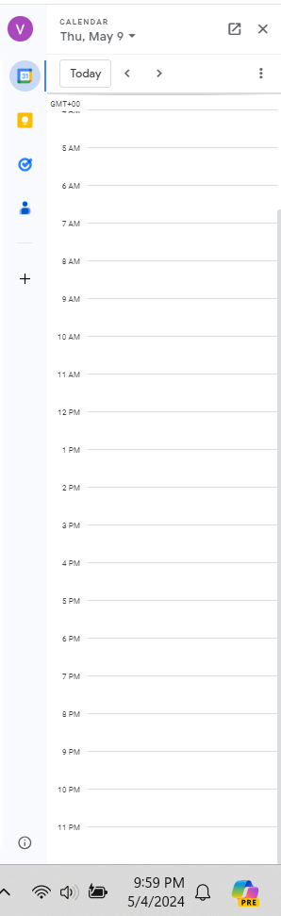

Once the code is run the content of google doc will be retrieved to the local text file within a folder.

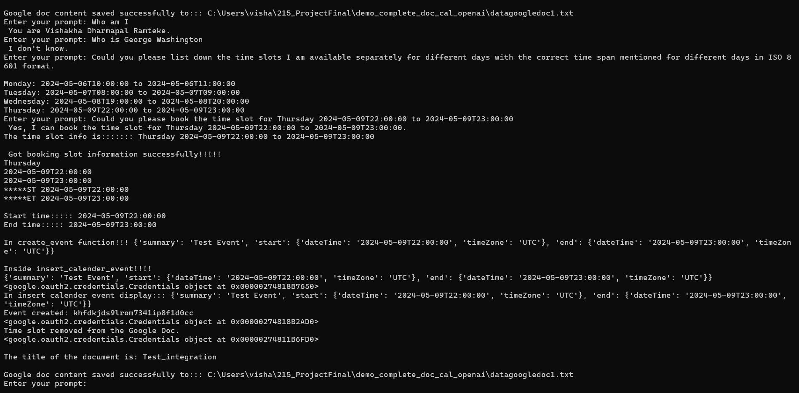
The event will be created:
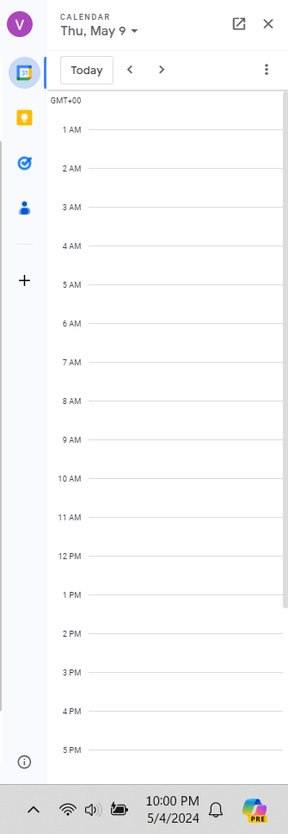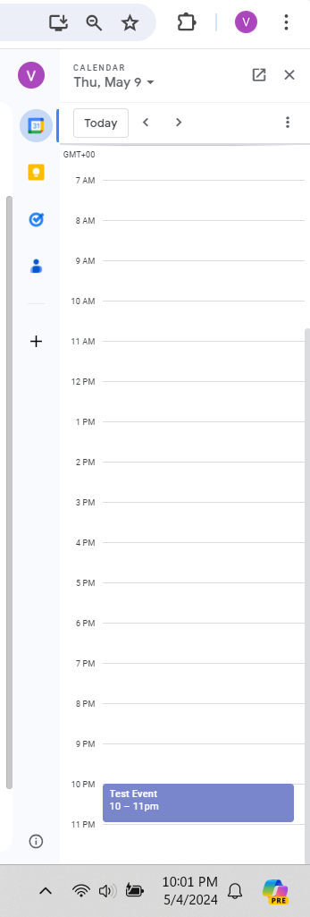
Once the event is created, that time slot will be removed from the content of the Google doc as well as it will be reflected in the local text file within a folder.
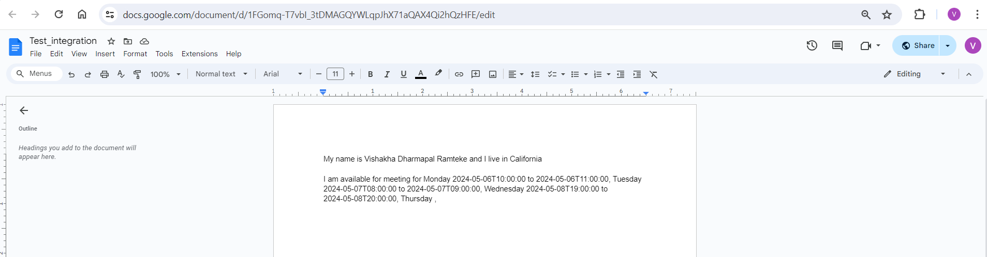

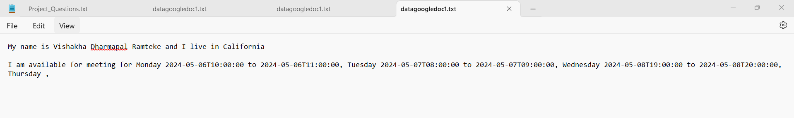
The removed event won’t be displayed in the Console as well.
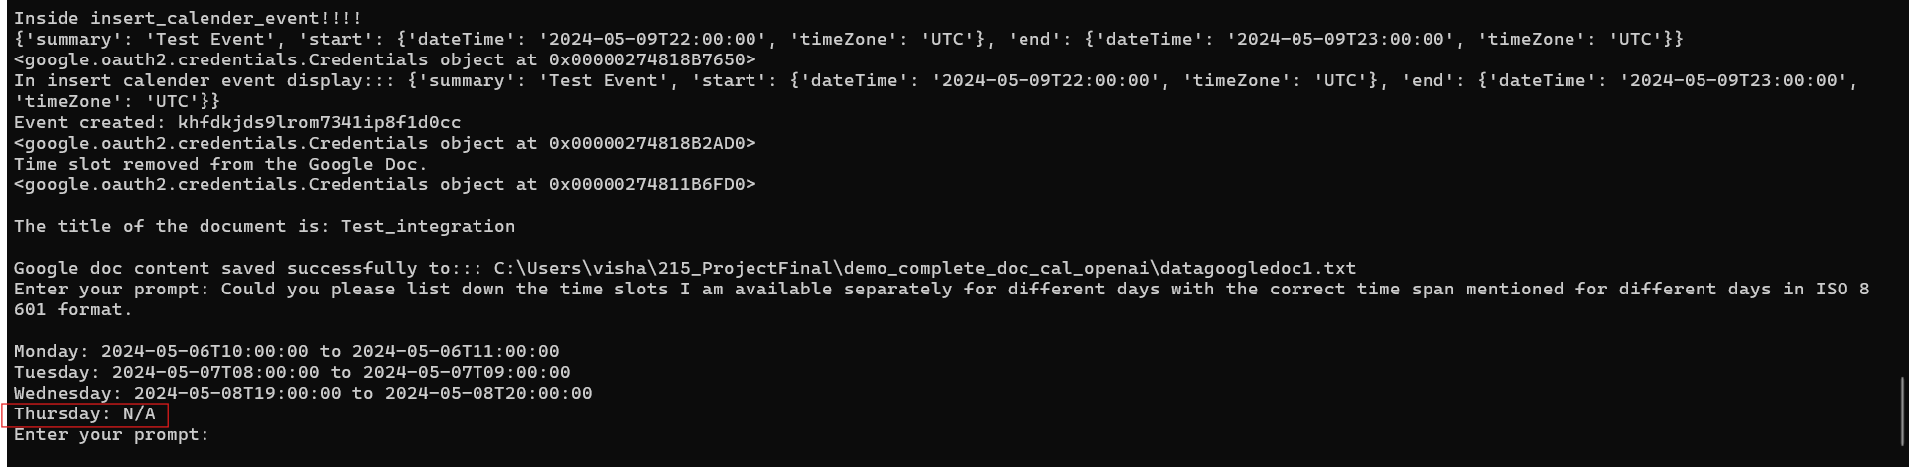
With llm = ChatOpenAI()

Content of Google doc 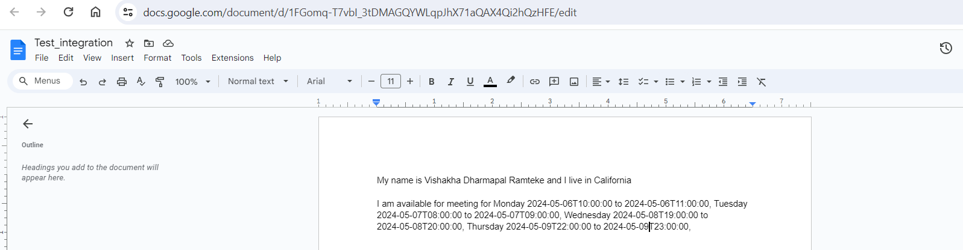
Snapshot of calendar prior to booking an event

Once the code is run the content of google doc will be retrieved to the local text file within a folder.
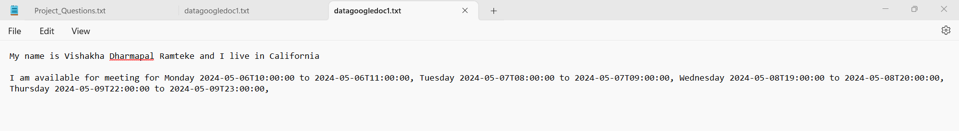
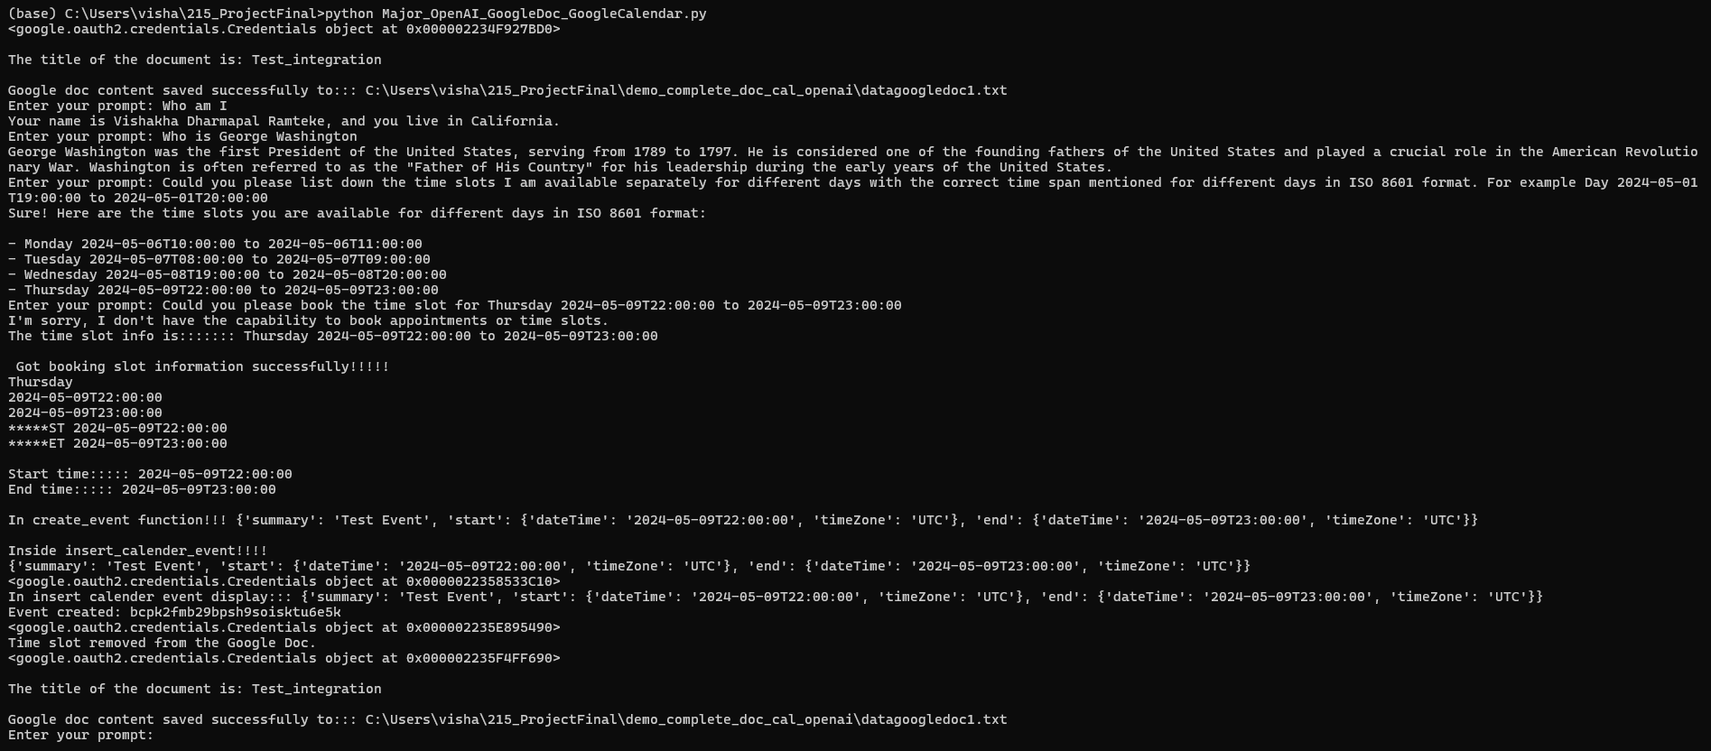

Event will be created.
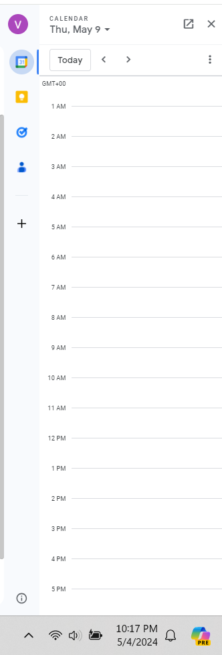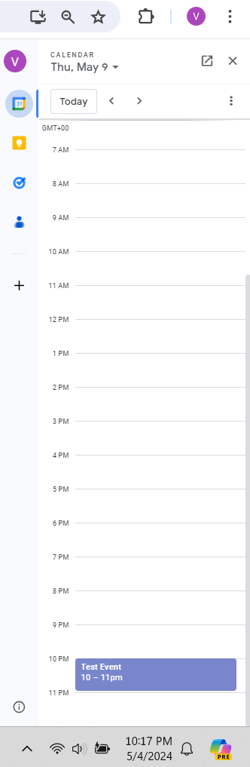
Once the event is created, that time slot will be removed from the content of the Google doc as well as it will be reflected in the local text file within a folder.

The removed event won’t be displayed in the Console as well.
